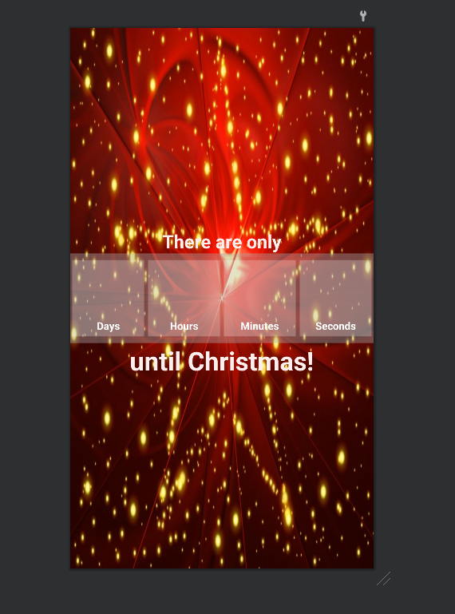

package com.lukec;  
  
import android.os.Bundle;  
import java.text.SimpleDateFormat;  
import java.util.Date;  
import android.os.Handler;  
import android.view.View;  
import android.widget.TextView;  
  
import androidx.appcompat.app.AppCompatActivity;  
  
public class MainActivity extends AppCompatActivity {  
  
 private TextView txtTimerDay, txtTimerHour, txtTimerMinute, txtTimerSecond;  
 private TextView tvEvent;  
 private Handler handler;  
 private Runnable runnable;  
  
 @Override  
 protected void onCreate(Bundle savedInstanceState) {  
 super.onCreate(savedInstanceState);  
 setContentView(R.layout.*activity_main*);  
  
 txtTimerDay = (TextView) findViewById(R.id.*txtTimerDay*);  
 txtTimerHour = (TextView) findViewById(R.id.*txtTimerHour*);  
 txtTimerMinute = (TextView) findViewById(R.id.*txtTimerMinute*);  
 txtTimerSecond = (TextView) findViewById(R.id.*txtTimerSecond*);  
 tvEvent = (TextView) findViewById(R.id.*tvhappyevent*);  
  
 countDownStart();  
 }  
  
 public void countDownStart() {  
 handler = new Handler();  
 runnable = new Runnable() {  
 @Override  
 public void run() {  
 handler.postDelayed(this, 1000);  
 try {  
 SimpleDateFormat dateFormat = new SimpleDateFormat(  
 "yyyy-MM-dd");  
 // Please here set your event date//YYYY-MM-DD  
 Date futureDate = dateFormat.parse("2022-02-17");  
 Date currentDate = new Date();  
 if (!currentDate.after(futureDate)) {  
 long diff = futureDate.getTime()  
 - currentDate.getTime();  
 long days = diff / (24 * 60 * 60 * 1000);  
 diff -= days * (24 * 60 * 60 * 1000);  
 long hours = diff / (60 * 60 * 1000);  
 diff -= hours * (60 * 60 * 1000);  
 long minutes = diff / (60 * 1000);  
 diff -= minutes * (60 * 1000);  
 long seconds = diff / 1000;  
 txtTimerDay.setText("" + String.*format*("%02d", days));  
 txtTimerHour.setText("" + String.*format*("%02d", hours));  
 txtTimerMinute.setText(""  
 + String.*format*("%02d", minutes));  
 txtTimerSecond.setText(""  
 + String.*format*("%02d", seconds));  
  
 } else {  
 tvEvent.setVisibility(View.*VISIBLE*);  
 tvEvent.setText("The event started!");  
 textViewGone();  
 }  
 } catch (Exception e) {  
 e.printStackTrace();  
 }  
 }  
 };  
 handler.postDelayed(runnable, 1 * 1000);  
 }  
  
 public void textViewGone() {  
 findViewById(R.id.*LinearLayout10*).setVisibility(View.*GONE*);  
 findViewById(R.id.*LinearLayout11*).setVisibility(View.*GONE*);  
 findViewById(R.id.*LinearLayout12*).setVisibility(View.*GONE*);  
 findViewById(R.id.*LinearLayout13*).setVisibility(View.*GONE*);  
 findViewById(R.id.*textView1*).setVisibility(View.*GONE*);  
 findViewById(R.id.*textView2*).setVisibility(View.*GONE*);  
 }  
}